Spring clean up
2023
APRIL 29TH
8 A.M. to 2 P.M.
20448 JUNCO RD, NORWALK

OPEN TO ALL MONROE COUNTY RESIDENTS.
NO COMMERCIAL/INDUSTRIAL WASTE.

Hazardous wastes will only be accepted at the spring cleanup, so now is the time to rid
your home and garage of hazardous wastes!
_____________________________________________________________________________
Accepted items at NO charge: Households / Farms
Up to: 5 gallons waste oil & 5 gallons oil filters & 5 gallons anti-freeze – over 5 gal of ea: .50₵/gal.
Hazardous waste: up to 250 lbs. per vehicle of any combo of the following:
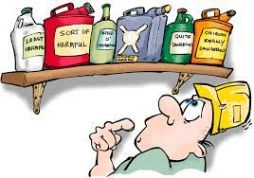
Lawn & farm chemicals All rechargeable batteries
Household cleaners Lithium & button batteries
Insect sprays (hearing aid, camera, etc.)
Paints / thinners Car batteries
Medications: Small helium/LP tanks <20 lbs.
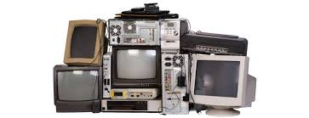
Pills, liquids, inhalers
Acceptable Items with Fees
*Now taking* Mattresses & Box springs: $15 ea.
TV’s: <25” - $15ea. Agricultural Plastic: $49/ton
>26” - $20 ea. Tires: 16.5₵/lb. or $330/ton
Bulbs: Fluorescent tubes: 8’ @ $1.00 ea. / 4’ @ .50₵ ea.
HID lamps, circle fluorescent, specialty lamps, halogens: $3 ea.
Refrigerant-containing appliances: (freezers, refrigerators, a/c, dehumidifiers) $10 ea.*
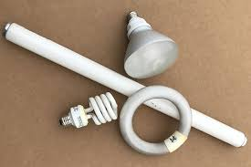
All other large appliances: $10 ea.*
Electronics: (ex. computer monitors, CPU, printers, copiers): $10 ea.*
*missing cords or disassembled, additional $5 ea.
We will not accept the following:
- Explosives (shotgun shells, fireworks, gunpowder, Picric acid, etc.)
- Radioactive materials
- Household or construction waste or large items (couches, chairs, demolition material)

Monroe County reserves the right to charge a fee for quantities of hazardous waste over household limits of 250lbs. Prices may be subject to change.
**This is not a business event: Businesses please contract with a permanent hazardous disposal service**

